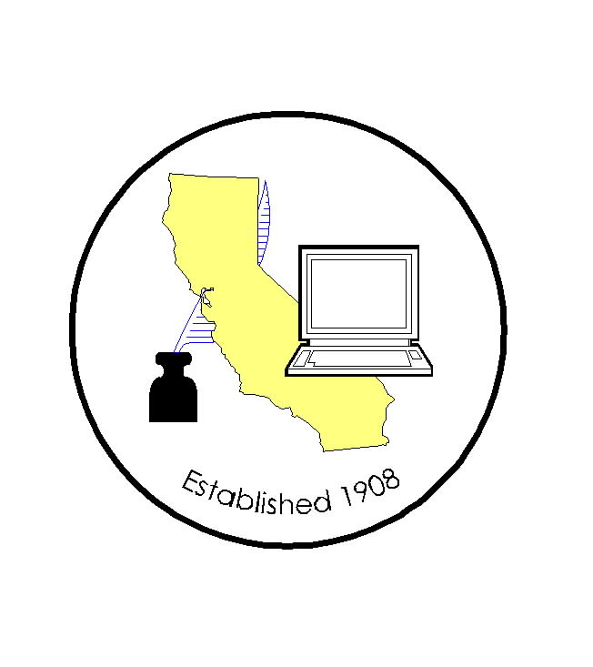
CALIFORNIA ASSOCIATION OF

CLERKS AND ELECTION OFFICIALS

March 4, 2009

TO: CACEO Members, Guests, Legislative Committee

FROM: Deborah Seiler and Jill LaVine, Co-Chairs

SUBJECT: CACEO LEGISLATIVE COMMITTEE MEETING

DATE: FRIDAY, March 13, 2008

TIME: 9:00 a.m. – 3:00 p.m.

LOCATION: Ramada Inn University
324 East Shaw Avenue
Fresno, CA 93710
Telephone: (559) 224-4040 or (800) 241-0756

SUBCOMMITTEE MEETINGS - Thursday, March 12, 2009

11 am – 1 pm SB 90 Reimbursement – Alice Jarboe, Chair

11am – 1 pm Voters with Specific Needs – Tim McNamara, Chair (MEET BY PHONE)

1 pm – 3 pm Provisional Voters – Lindsey McWilliams, Diane Jones, Co-Chairs

3 pm – 5 pm HAVA/Certification – Tim McNamara Chair

LEGISLATIVE COMMITTEE – Tentative Agenda

8:30 am Continental Breakfast

9:00 am Welcome and Introductions
Approval of Minutes of February 6, 2009 meeting

News from our City Clerk Representative
Discussion of three city legislative proposals

9:30 am Discussion of Bills
AB 257 Adams AB 1367 Fletcher
AB 269 Silva AB 1415 Adams
AB 441 Hall AB 1424 Knight
AB 467 Coto AB 1440 Swanson
AB 686 Ruskin AB 1490 Galgiani
AB 753 Adams AB 1519 De La Torre
AB 780 Perez AB 1525 Beall
AB 895 Furutani SB 172 Florez
AB 909 Feuer SB 288 Yee
AB 971 Krekorian SB 321 Benoit
AB 1096 Galgiani SB 370 runner
AB 1121 Davis SB 387 Hancock
AB 1134 Mendoza SB 465 Huff
AB 1228 Yamada SB 582 Dutton
AB 1271 Krekorian SB 740 Cedillo
AB 1308 Hagman
AB 1326 Huffman
AB 1335 Lieu
AB 1337 Evans
AB 13340 Lowenthal
AB 1356 Berryhill

Noon Lunch

1:00 pm Information Only Bills
AB 257 Adams AB 1149 Davis
AB 624 Monning AB 1514 Hayashi
AB 742 Saldana AB 397 Jeffries

Discussion Items:

Report on March 4 hearing in Sacramento
Report on Status of PEMT Working Group
USPS’s 95-Day NCOA Requirement
Susan Davis Legislation (attached)

2:00 pm Subcommittee Reports

3:00 pm Adjourn

